Name of Student: HARPAL BIDAWAT | PRN:25070122080
Semester: III | Year : AY 2026-27
Subject: Programming with Java
ASSIGNMENT No :
TITLE : JDBC ResultSet
Problem Statement
Develop a Java application using JDBC to navigate and retrieve records from a ResultSet.
Learning Objectives
To navigate and retrieve records using ResultSet methods.
Programme
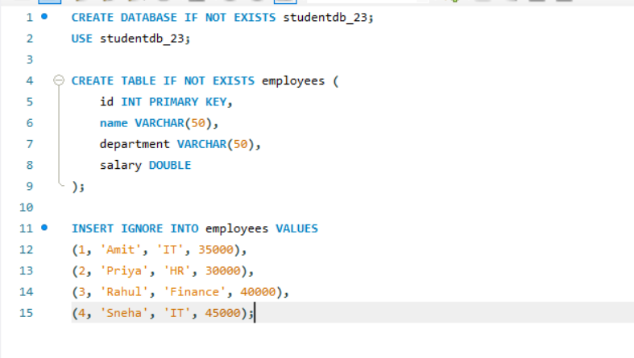
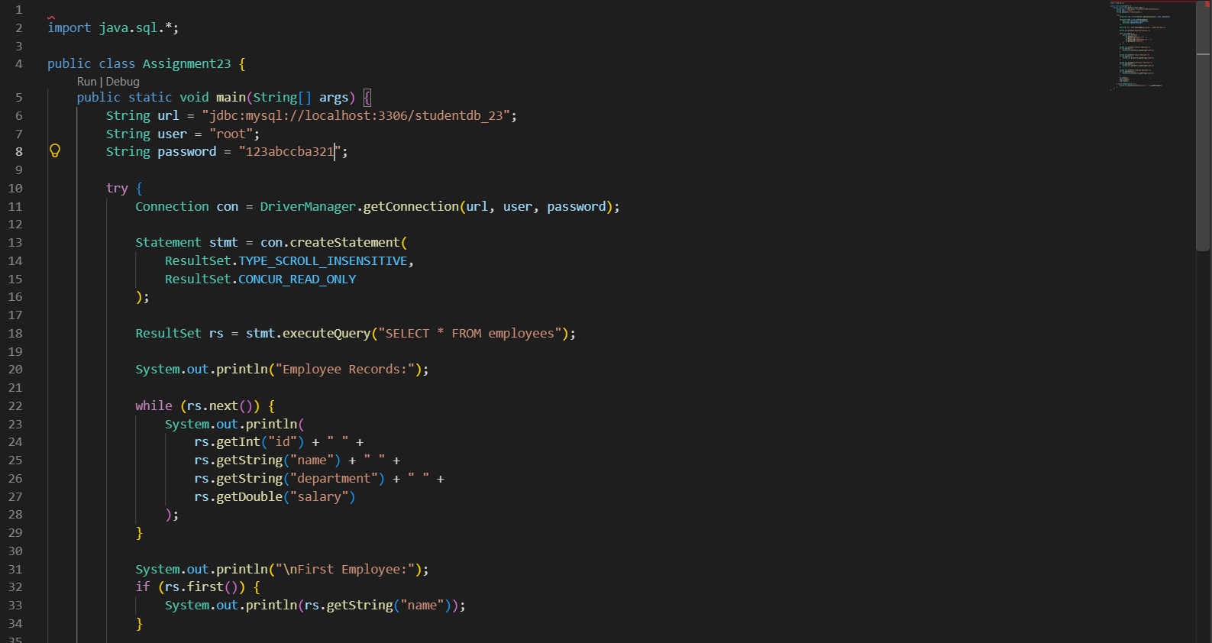
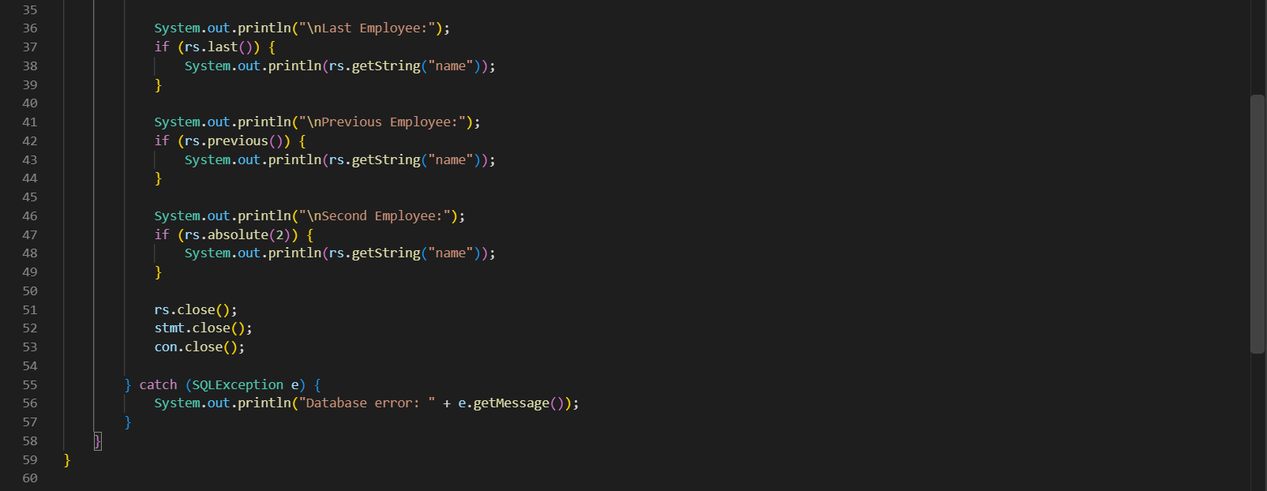
Output
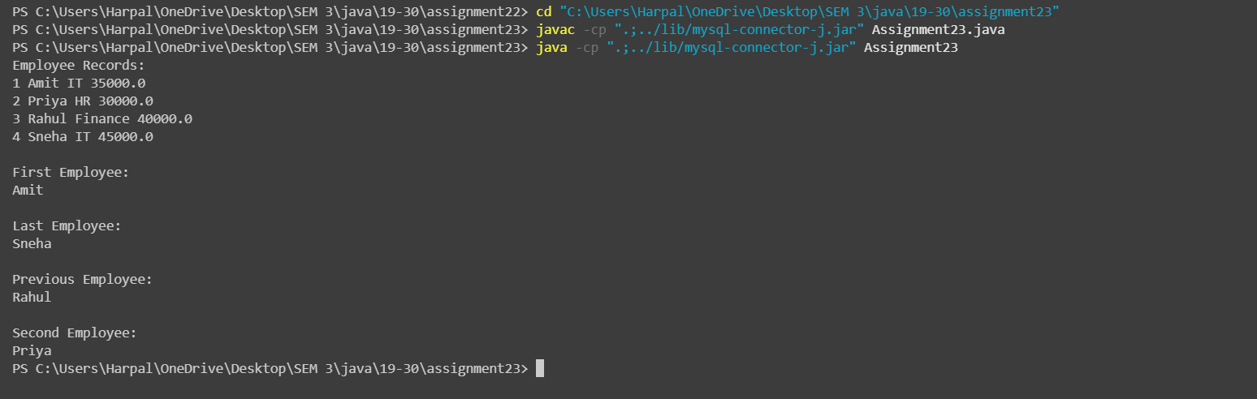
Conclusion
The program successfully retrieved employee records from MySQL using JDBC and the ResultSet interface. It demonstrated record navigation using next(), first(), last(), previous(), and absolute() methods.

